SACHIN DIGRA

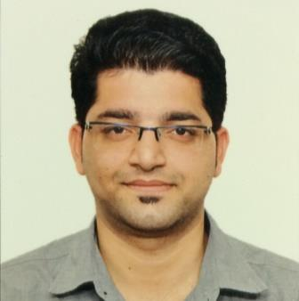
Personal Details

S/O:Sh.Rattan Chand

Gender: Male Marital Status: Single

D.O.B.: 09/02/1991 Language Proficiency: English, Hindi ,Punjabi

Permanent Address: H.no.-182,A/C,Old Janipur,Jammu,J&K.

Current Address: Flat no-203,B-23,Saraf Chaudhary Nagar CHS Ltd.,Thakur Complex, Kandivali(East),Mumbai-400101.

E-mail: sachin.digra@yahoo.com Phone: +919820315713,+919595569951

Career Objective

To seek a job in a reputed organization which provides a platform and opportunities to learn and grow at professional as well as personal level and extracting the best out of me, thereby directing my future endeavors as an asset to the organization.

Qualification

Qualification | Institute/College/School | University/Board | Month &Year of passing | Percentage
MBA(Marketing) | Sinhgad Institute of Business Administration and Research, Pune | University of Pune | June 2015 | 68.60%
PGDBM(Supply Chain Management) | Poona College of Management Studies &Entrepreneurship, Pune | University of Pune | July 2015 | 69%
B.B.A | Trikuta College of Computer Science&Management Studies,Jammu,J&K | University of Jammu | July 2013 | 57.21%
H.S.C. | S.R. Public School,Jammu,J&K | J&K BOSE | May 2009 | 59.73%
S.S.C. | Sai Montessori Hr.Sec. School,Jammu,J&K | J&K BOSE | May 2007 | 68.6%

IT Proficiency

- Operating System : WINDOWS (95, 98, 2000, XP, Vista, 7,8) , MACHINTOSH
- Software Packages : MS- Office 2010 (Word, Excel, Power Point),Adobe Photoshop,Adobe Reader,
Adobe After Effects , Pinnacle Studio.
- Work Experience : Working with IndusInd Bank as Branch Acquisition Manager for Credit
card and Personal loan from 05-01-2015 to till date

Extra-Curricular Activities – Achievements

- Presentation for Research Paper titled "Challenges in Agricultural Marketing" in STATE LEVEL seminar on"Emerging Issues in Corporate Strategies".
- Certificate Course in "Digital&Social Media Marketing".
- Passed Common Written Examination of Clerical Cadre conducted by INSTITUTE OF BANKING PERSONNEL SELECTION.
- Two Months’Summer Intermship Programme under Project title “To Study Sales of MDU”at TATA SKY PVT.LTD.,Pune.
- Participated in various management activites, Inter-college competition individually and/or in a team.
Strengths

- Team Builder
- Leadership Qualities
- Focused & Ambitious
- Adaptable
- Self- confident
Weakness

- Tend to trust people.
- Pay a lot of time into details thus time consuming.
Hobbies
- Fashion Photography, Playing Cricket
- Listening to music.
- PC Games
Declaration

I hereby declare that the above-mentioned information is correct up to my knowledge and I bear the responsibility for the correctness of the above-mentioned particulars.
Date: --/--/--

Place: (Sachin Digra)

